**BP315 Business Sub-Process Design Document**

**SAP Service Cloud – SAP FSM Integration**

**Cross Industry/Customer Insight and Growth**

**SAP – Cloud for Customer**

Table of Contents

1 Overview 1

1.1 Change History 1

1.2 RASCI 1

1.3 Approval Detail 1

1.4 Other Related Documents 1

2 Business Process Overview 1

2.1 High level requirements 1

2.2 Key Value Drivers for the Business Process 1

2.3 Leading Practice Inputs 1

3 Business Sub-Process Description 1

3.1 Business Sub-Process diagram 1

4 Sub Process Activities 1

4.1 Activity List 1

4.2 Inbound Communication 1

4.3 Outbound Communication 1

4.4 Test Conditions 1

5 Sub-Process Variation 1

5.1 Business Unit Led 1

5.2 Geography/Legal Entity Led 1

6 Role Definition & Organisational Impact 1

6.1 Role/Skill Class Inventory 1

6.2 Role Summary 1

6.3 Organizational Impact 1

7 Process Fitness & Gap Analysis 1

7.1 Process Fitness 1

7.2 Gap Analysis 1

8 RICEFW 1

8.1 Reports 1

8.2 Interfaces (Inbound / Outbound) 1

8.3 Conversions 1

8.4 Enhancements 1

8.5 Forms 1

8.6 Workflows 1

9 Integration Points 1

9.1 Integration Issues 1

9.2 Other issues 1

# Overview

Omnichannel support for tickets in SAP Service cloud is further extended to resolve the customer issues quickly with end to end field service management and crowd services. This solution enables the service organization achieve end to end service process.

This AI powered platform (FSM) provides new generation scheduling of field service activities and easy to operate mobile app enables technicians in the field to perform their routine work. Service organizations can shape and develop service networks beyond their own workforce with its excellent crowd-sourcing capabilities.

Technologies in use:

SAP Service Cloud (C4C)

SAP Field Service Management (FSM)

SAP Cloud Platform Integration (CPI) - Middleware

## Change History

|  |  |  |  |  |
| --- | --- | --- | --- | --- |
| Ver. | Date | Summary of Changes | Author | Transport Number |
| V1.0 | 13/09/2019 | Initial document | Vamsi Singaraju | N/A |
| V1.1 | 12/03/2020 | Format changes as per new template | Praveen Dadhich | N/A |
|  |  |  |  |  |

## RASCI

|  |  |  |  |
| --- | --- | --- | --- |
| RASCI | Role | Name | Phone |
| N/A | N/A | N/A | N/A |
|  |  |  |  |
|  |  |  |  |

R: Responsible; A: Accountable; S: Support; C: Contribute; I: Information;

## Approval Detail

|  |  |  |  |
| --- | --- | --- | --- |
| Review # | Date | Name & Position of Approver | Signature |
|  |  |  |  |
|  |  |  |  |

## Other Related Documents

Please insert links/references to related documents (issues, data entities, etc.)

|  |  |
| --- | --- |
| Related Document | Comment |
| BP310_C4C_C4C Integration with FSM for Master Data and Service Ticket | Business Process |
| TE586_C4C_C4C Integration with FSM for Master Data and Service Ticket | Test Script |
| AP322_C4C_C4C Integration with FSM for Master Data and Service Ticket | Configuration Guide |
| TR435_C4C_C4C Integration with FSM for Master Data and Service Ticket | End User Guide |

# Business Process Overview

SAP has introduced the standard integration between SAP C4C and SAP FSM. Service Ticket can be released to FSM to fix the issue with best available technician.

Service technicians can use the FSM Mobile app to accept the assignment, provide the T&M details and close the assignment in customer location once fixed Standard integration between SAP Service Cloud and SAP Field Service Management intended to orchestrate seamless end to end customer service excellence by resolving customer issues quickly.

Customer sends email to a specified email address which is preconfigured as a channel in C4C. The email will automatically get converted to a ticket in C4C and a service agent will be assigned to the ticket. An agent starts working on the ticket, analyses it and determines if the ticket needs to be forwarded to a field service agent to work on it further in customer premise to fix the issue and if required, the ticket is sent to SAP Field Service Management.

When a Technician/Field Service agent receives the ticket, he/she accepts the assignment and visits the customer location, checks-in the assignment through FSM App to fix the issue. Details like efforts, expenses and consumables are entered in the FSM app and at the end, generates the work summery report. Manager / Admin approves the expenses, efforts and consumables of the assignment and marks the ticket as complete in FSM. Then the ticket is replicated back to C4C with all the latest updates.

Note: C4C will be the master system for service ticket creation. Customers will send emails, phone calls etc. regarding the issue to customer service agent in C4C. If required, the tickets can be forwarded to SAP FSM if need on field support.

Below diagram is considered for this user story:

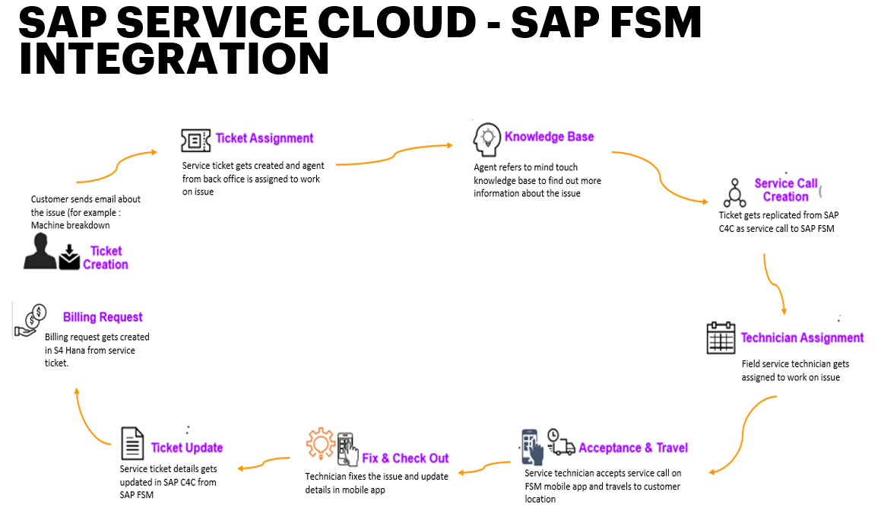

## High level requirements

Below are the high-level requirements for this scenario:

Service tickets are getting created in SAP service cloud from different sources, and these service tickets require to transfer to SAP Field Service Management (FSM) system with all details.

All service tickets in FSM system needs to be assigned to relevant field service technician.

Once the tickets are closed by service technician in SAP FSM, ticket details should flow back to SAP C4C to update the ticket details and S/4Hana for further billing process.

## Key Value Drivers for the Business Process

Quick redirection of service tickets from service agent to field service technician on a click of a button.

Fast resolution of customer issues with the help of FSM.

Ease of finding the best service technician for the customer issues, either in-house or external.

Increase in the revenue and reduce the field service cost by minimizing unproductive time of service technician.

Build customer loyalty and trust with immediate resolutions.

## Leading Practice Inputs

With eco system integration brand experience, customer experience, employee experience and product experience are enriched.

Greater transparency and more effective planning by Resource Planner.

Optimized communication between office and field service.

Enhanced customer experience.

Plausible data entry.

# Business Sub-Process Description

The sub-process describe how business leverage this solution to provide best service on time to the customer also how it provides easy access to customer for raising service request.

## Business Sub-Process diagram

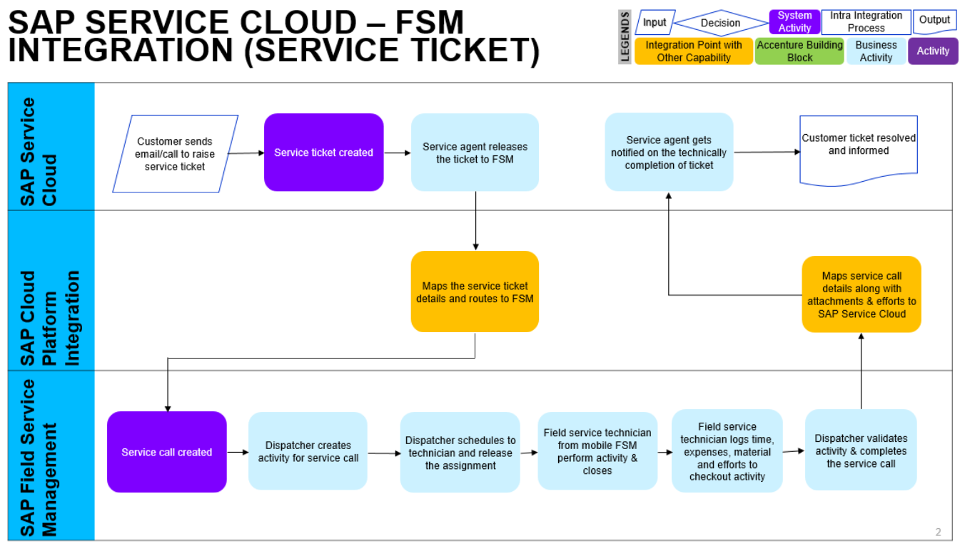

# Sub Process Activities

**Customer send email to support desk (SAP C4C)**

Customer send email to support desk email about informing the issue.

In This scenario customer’s machine break and he/she wants to get it repaired so sends email stating the issue.

**Dispatcher’s planning and dispatching board (SAP FSM)**

Dispatcher/service manager has access to planning and dispatching board where he can monitor all the tickets created associated activities. He can assign the activities to their own employees through drag and drop.

**Notification on ticket to crowd field service technician (FSM App)**

Service technician will receive an email with the service call details with the options to accept/reject based on his availability. On accept it gets added to his calendar whereas on reject the activity goes back to the scheduling board for rescheduling.

**Mobile push notification and the worklist**

Once Field service technician accepts the activity, he will get push notification on mobile from there he can sync the mobile FSM application to get the latest updates of the ticket and activity. Worklist attached with the activity helps the technician to perform the task (Accept, Travel, Work, Preview and Checkout) on each step’s timer runs to record the time taken also he can log his expenses, claims or materials used if any.

**Dispatcher’s notification and the ticket closure**

When the activity is closed by the field service technician with the customer signature on PDF then dispatcher gets notification on the close of activity. He will check for further actions if not will close the service call by that customer will also be notified and the service process is technically completed. Then the billing happens in S4 Hana.

## Activity List

It maps to the BP317, Activity definition document if applicable for the project & also has references in the process/sub process diagram.

|  |  |  |  |  |
| --- | --- | --- | --- | --- |
| Name | Description | Transaction Code,  if relevant | Roles involved | Regulatory /Other Controls |
| Create Account | In C4C create account, it will be replicated to FSM | - | Business Executive |  |
| Create Contact | Create contact for previously created account, it replicates to FSM | - | Business Executive |  |
| Create Employee | Create employee in C4C, he will be the responsible employee to work on tickets. | - | Business Executive |  |
| Create Product | Create product in C4C, they are replicated in FSM as Items | - | Business Executive |  |
| Create Registered Product | Create registered product in C4C by providing customer and Item (both should be previously created and replicated in FSM) | - | Business Executive |  |
| Create Ticket in C4C | Customer sends email to support desk and ticket gets created in SAP C4C automatically. | - | Customer |  |
| Dispatcher views the ticket assignment | Auto scheduler finds the best matching technician also dispatcher can reschedule |  | Dispatcher/ Service Manager |  |
| Field service technician acceptance | Service technician can accept or reject then follows the worklist to complete the activity | - | Field Service Technician |  |
| Activity completed | Technician checkout and gets it verified with the customer signature |  | Field Service Technician |  |

## Inbound Communication

The Inbound Communication needs to be specifically documented for the client specific situation, like interfacing with external systems, workflow, form & Medium of communication.

|  |  |  |  |  |
| --- | --- | --- | --- | --- |
| Activity | Type (email, form, handoff, etc) | Automatic/Manual | Source | Description |
| 1 | Business partner replication | Automatic | SAP Service Cloud | Business partner replication from SAP Service cloud to SAP Field Service as Business Partner |
| 2 | Contacts replication | Automatic | SAP Service Cloud | Contacts replication from SAP Service cloud to SAP Field Service associated to Business Partner contact |
| 3 | Employee replication | Automatic | SAP Service Cloud | Employee replication from SAP Service cloud to SAP Field Service as People |
| 4 | Product replication | Automatic | SAP Service Cloud | Product replication from SAP Service cloud to SAP Field Service as Items |
| 5 | Registered production | Automatic | SAP Service Cloud | Registered production from SAP Service cloud to SAP Field Service as Equipment’s |

## Outbound Communication

The Outbound Communication needs to be specifically documented for the client specific situation, like interfacing with external systems, workflow, form & Medium of communication.

|  |  |  |  |  |
| --- | --- | --- | --- | --- |
| Activity | Type (email, form, handoff, etc) | Automatic/Manual | Source | Description |
| N/A | N/A | N/A | N/A | N/A |
|  |  |  |  |  |

## Test Conditions

This section captures Test conditions for this sub process for the any specific client requirements. Generic test conditions for this sub process will be within the AAES test scripts.

|  |  |  |
| --- | --- | --- |
| Number | Test Condition – Action | Expected Result |
| 1 | Available under test script document | TE586_C4C_C4C Integration with FSM for Master Data and Service Ticket |
|  |  |  |

# Sub-Process Variation

## Business Unit Led

N/A

## Geography/Legal Entity Led

N/A

# Role Definition & Organisational Impact

The content in this section will serve as input for the training and performance support team’s deliverables.

## Role/Skill Class Inventory

|  |  |  |
| --- | --- | --- |
| Role | Skills | Knowledge |
| Business Executive | SAP C4C | Master data and related transactional data and basic integration set up |
| Dispatcher/Manager | SAP Field Service | Business rules, configuration and setup |
| Field Service Technician | SAP Field Service | Repair skill and service call |

## Role Summary

|  |  |  |
| --- | --- | --- |
| Role | List of Steps | SAP Transaction |
| N/A | N/A | N/A |
|  |  |  |

## Organizational Impact

|  |  |  |  |  |
| --- | --- | --- | --- | --- |
| Reference # | Impact Description | Impact (H/M/L) | Impact Type | Impacted Groups |
| N/A | N/A | N/A | N/A | N/A |
|  |  |  |  |  |
|  |  |  |  |  |

# Process Fitness & Gap Analysis

## Process Fitness

|  |  |  |  |  |
| --- | --- | --- | --- | --- |
| Req ID | Short Description | Long Description | Req. Type | Accenture Reusable Assets |
| N/A | N/A | N/A | N/A | N/A |
|  |  |  |  |  |

## Gap Analysis

|  |  |  |  |  |  |  |
| --- | --- | --- | --- | --- | --- | --- |
| Country/ Region/ Business Impacted | Gap Description | Legal Req. (Y/N) | Magnitude of Impact (L/M/H) | Solution Type | RICEFW No. | Ref. to Req. id. |
| N/A | N/A | N/A | N/A | N/A | N/A | N/A |
|  |  |  |  |  |  |  |

# RICEFW

## Reports

|  |  |  |  |  |  |
| --- | --- | --- | --- | --- | --- |
| Client XYZ  RICEFW # | Report Description | Complexity (H/M/L) | Comments | Use from myConcerto/ARTL (New/Rework/Rep) | Ref # from RICEFW inventory |
| N/A | N/A | N/A | N/A | N/A | N/A |
|  |  |  |  |  |  |
|  |  |  |  |  |  |

## Interfaces (Inbound / Outbound)

|  |  |  |  |  |  |
| --- | --- | --- | --- | --- | --- |
| Client XYZ  RICEFW # | Interface Description | Complexity  (H/M/L) | Comments | Use from myConcerto/ARTL (New/Rework/Rep) | Ref # from RICEFW inventory |
| N/A | N/A | N/A | N/A | N/A | N/A |
|  |  |  |  |  |  |

## Conversions

|  |  |  |  |  |  |
| --- | --- | --- | --- | --- | --- |
| Client XYZ  RICEFW # | Conversion Description | Complexity  (H/M/L) | Comments | Use from myConcerto/ARTL (New/Rework/Rep) | Ref # from RICEFW inventory |
| N/A | N/A | N/A | N/A | N/A | N/A |
|  |  |  |  |  |  |

## Enhancements

|  |  |  |  |  |  |
| --- | --- | --- | --- | --- | --- |
| Client XYZ  RICEFW # | Enhancement Description | Complexity  (H/M/L) | Comments | Use from myConcerto/ARTL (New/Rework/Rep) | Ref # from RICEFW inventory |
| N/A | N/A | N/A | N/A | N/A | N/A |
|  |  |  |  |  |  |

## Forms

|  |  |  |  |  |  |
| --- | --- | --- | --- | --- | --- |
| Client XYZ RICEFW # | Form Description | Complexity (H/M/L) | Comments | Use from myConcerto/ARTL (New/Rework/Rep) | Ref # from RICEFW inventory |
| N/A | N/A | N/A | N/A | N/A | N/A |
|  |  |  |  |  |  |

## Workflows

|  |  |  |  |  |  |
| --- | --- | --- | --- | --- | --- |
| Client XYZ RICEFW # | Workflow Description | Complexity (H/M/L) | Comments | Use from myConcerto (New/Rework/Rep) | Ref # from RICEFW inventory |
| N/A | N/A | N/A | N/A | N/A | N/A |
|  |  |  |  |  |  |

# Integration Points

Generic Integration touch points have been highlighted in this section. It covers dependencies or prerequisites arising from other processes or sub processes. This information should lead to cross functional discussions between different work streams to sort out the interdependencies.

SAP Field Service is integrated with SAP Service cloud for master data replication.

Business partner replication from SAP Service cloud to SAP Field Service as Business Partner

Contacts replication from SAP Service cloud to SAP Field Service associated to Business Partner contact

Employee replication from SAP Service cloud to SAP Field Service as People

Product replication from SAP Service cloud to SAP Field Service as Items

Registered products from SAP Service cloud to SAP Field Service as Equipment.

## Integration Issues

|  |  |  |  |  |
| --- | --- | --- | --- | --- |
| Issue # | Issue Description | Impact | Status | Resolution |
| N/A | N/A | N/A | N/A | N/A |
|  |  |  |  |  |

## Other issues

|  |  |  |  |  |
| --- | --- | --- | --- | --- |
| Issue # | Issue Description | Impact | Status | Resolution |
| N/A | N/A | N/A | N/A | N/A |
|  |  |  |  |  |

#### Revision History

|  |  |  |  |
| --- | --- | --- | --- |
| Date | Version | Description | Author |
| 13.09.2019 | V1.0 | Business Sub-Process Design Document  SAP C4C – SAP FSM Integration | Vamsi Singaraju |
| 12.03.2020 | V1.1 | Format changes as per new template | Praveen Dadhich |